
www.caealliance.com

COAL, CLEAN EMISSIONS CONTROL
& THE ENVIRONMENT

ADVOCATES FOR:
Cleaner Air
Affordable Energy Rates
Energy Supply Reliability
Responsible management of energy resources
Preserving the Presence of Industry and
Business in Ontario

WHO WE ARE:
The Clean Affordable Energy Alliance formed early in May, 2005 as a result of the plans announced by the McGuinty government to restructure the energy system in Ontario. Common concerns for our community and our province brought us together; concerns for residents, industry, business, farmers and labour. The CAE Alliance currently has 2 chapters, CAE Lambton, and CAE Haldimand-Norfolk.

OUR MESSAGE:
We believe that the current energy policy is a recipe for economic disaster. Important, expensive decisions are being made that will impact the adequate supply and affordability of energy in Ontario for decades to come. A critical component is the removal of an additional 6500MW of publicly owned coal-fired electricity from the grid and subsequent replacement with natural gas-fired generation. All ratepayers, including business and industry, will experience some degree of financial loss through spiraling utility costs. Reliable, affordable power in Ontario is being jeopardized.

THE ENVIRONMENTAL ISSUES:

The McGuinty government is justifying the coal closure based on pollution/health issues, and CO₂/Kyoto compliance. Unfortunately however, an assessment has not been conducted with regard to the full environmental ramifications, costs to the Ontario consumers, or the impact on the provincial economy.

1. The Select Committee on Alternative Fuels – Final Report - June, 2002

• An all-party Committee of the Ontario Legislature, was appointed on June 28, 2001 with a broad mandate “to investigate, report and recommend ways of supporting the development and application of environmentally sustainable alternatives to our existing fossil [carbon-based] fuel sources”

• A very comprehensive study resulted. Committee members attended a variety of fuel and energy conferences; visited sites in North America and elsewhere; shared experiences with the full Committee which directly influenced many of the recommendations; and reviewed the experience of many other jurisdictions in North America and internationally on alternative energy matters. Extensive research was conducted on best practices in leading jurisdictions; public hearings, meetings, and site visits were conducted. The Committee members met with and received oral or written submissions from some 218 individuals and organizations. Reports from all of the meetings, and written and oral submissions were shared for the purpose of preparing a report for use in strategic energy planning - basically what the OPA purported to do, only more extensively, and over a greater period of time.

• The motivating factor for the process was the gradual transition to renewable energy for Ontario’s future. The Committee put forth firm policy recommendations and timetables to guide the development of a comprehensive Ontario alternative fuels and energy plan.

Established Priorities

Foundational to the recommendations for power planning referred to in The Select Committee on Alternative Fuels, Final Report, was the advice to “Ensure that the relative cost of different energy sources, fiscal implications, energy security, impact on job creation, export development and the provincial economy were all considered.”

Recommendations Included:

• The use of a ‘Life Cycle Costing’ approach to assess costs and impacts of new fuel/energy technologies. In assessing the costs of new alternative fuel/energy sources, comparisons should be made with the costs of new conventional sources of fuel/energy.

• Ontario should work to eliminate its reliance upon coal based power generation by the year 2015, unless future technological advances result in dramatically reduced air emissions that are equivalent to or lower than emissions from natural gas generation. At the same time, Ontario should continue to adopt aggressive air pollution requirements to promote clean energy options. Traditional carbon-based fuel generation constitutes only 19% of Ontario’s electricity generation by fuel type. In some Canadian provinces, such as Alberta, coal-fired generation provides 81% of electricity generation (1999 figures).

• The consideration to use natural gas in place of coal could cause a major increase in demand for this fuel, and a resulting increase in price. This could affect the long-term supply and price of natural gas within Ontario.

• Oil and natural gas-fired generation should also be phased out.

Current Policy

The all party report is cited by the current government as indication that the other political parties support their promise and policy to remove coal-fired generation by 2007-2009. However, the CAE Alliance maintains that:

• An objective, comprehensive use of “Life Cycle” assessment approach to both cost and environmental impact will demonstrate that maintaining coal fired power plants, with emissions control upgrades, is a superior decision than switching to natural gas-fired power generation.

• Since the all-party Report was formulated in 2001-2002, emissions control technology has been proven effective on 2 of the 4 units at Lambton Generation Station. (See the attached letter/report from Energy Probe)

• Coal-fired emissions can be reduced to within 1% of the emissions of natural gas-fired emissions, for about 20% of the billions of associated costs of switching to natural gas.

• The replacement of coal-fired generation with natural gas power production will cause a major increase in costs for fuel, resulting electricity, gas infrastructure, gas supply for home heating and will negatively impact industrial use of gas to the detriment of the Ontario economy.

• Energy security and self-sufficiency has become a priority issue. All credible sources report that North American natural gas production is in decline. New and unconventional sources of gas are not producing as hoped. Optimistic assessments of future natural gas price and supply rely on significant imports of liquefied natural gas (LNG). The environmental ramifications of LNG, and other non traditional sources of natural gas have not been reported. LNG supplies are tied into massive infrastructure and permitting procedures. We question the wisdom of reliance upon international resources in light of unstable political situations in source nations.

2. Health Costs

• The CAE Alliance has requested copies of all information and documentation used by the Ministry of Energy to justify the coal closure. The only document made available to us was a copy of the April, 2005 report, “Cost-Benefit Analysis – Replacing Ontario’s Coal-Fired Electricity Generation”.

• A review of that document was conducted by Tomas Hughes Consulting (Corunna) Ltd. on behalf of the CAE Alliance. A copy of this review of the government report is included with this paper. To summarize, the amounts claimed as costs associated with coal fired generation do not represent health care costs incurred by the Ontario public. Of the $3.0 Billion health impacts, $2.8 Billion, is a theoretical “value”, not an actual cost, as we are led to believe. In addition these values are determined by methods having high degrees of margin for error.

• A quote from the government Cost Benefit Report states, “In actual fact, it is impossible to identify which specific deaths that occur over a given time are actually attributable to pollution. Air pollution is a contributory factor in a multitude of deaths and is almost never the overriding or irrefutable single cause of death.” The methodology used to determine health damages would lead one to believe that, if a 75 year old male, a smoker and 40 pounds overweight, goes out to cut his lawn at 2 p.m. on a hot, smoggy August afternoon and expires of a heart attack, his death is attributable to air pollution and cost the Ontario taxpayers $4.3 million.

• Thermal generating plants in Ontario (coal, gas and oil) produce about 6-7% of smog causing pollutants. If, as is reported, this contribution to overall air quality causes 668 deaths annually, then air pollution would be killing over 11,100 people in Ontario annually. If $3.0 billion really is the annualized health damages associated with the coal fired generation, then the total health damages for all pollution would be $50 billion, 60% more than the total health care budget for the province.

• In spite of the statements that air pollution is a “contributory” cause, and that pollution from the coal fired power plants is less than 7% of the provincial air quality, coal fired generation is being assigned the full penalty, rather than a “contributory penalty”. According to the statistical report, the government believes that every man women and child in Ontario is prepared to pay $192/year to possibly extend the life, by a few moments, weeks or years, of 668 random people whose primary cause of death will be something other than pollution, while still being subject to 94% of the remaining air pollution.

• Researchers from the University of Glasgow, UK, carried out a comprehensive study of the relationship between pollution and mortality in Toronto. While not totally ruling out some link, after looking at 567 trillion combinations of possible factors, they could find no statistical evidence linking mortality to pollution.

• Two of Ontario’s coal fired power plants have been retrofitted with clean emissions technology. If we were to use the government report figures unquestioned, it would still be better to keep these 2 units, Lambton Units 3 and 4 on line, than to switch to natural gas.

• Atikokan and Thunder Bay Generating Stations were not considered significant enough, regarding emissions to be included in the government commissioned study. Monitoring equipment installed for a number of years on behalf of the Ministry of the Environment in these northern regions demonstrated that there is no impact on air quality as a result of the coal-fired power plants in these communities.

3. Air Pollution

• Environment Canada reports that pollutant releases in Ontario, fell 24% between 1998 and 2002. (News Release May 24, 2005)

• According to the Ontario Ministry of the Environment, approximately 55% of smog producing emissions originate in the U.S. from sources such as industry, transportation and fossil fuel plants that are not equipped with emissions control technology.

• Atmospheric modeling documented during a smog event (RWDI study) determined that natural gas fired generation produced less ozone, but coal produced less fine particulate. The overall difference is in the 1 – 2% range, between the two fossil fuels.

• Thermal generation, including natural gas, oil and coal, contributes about 6-7% to the provincial air pollution according to Ministry of the Environment information. Clean emissions technology can reduce that amount to 1%.

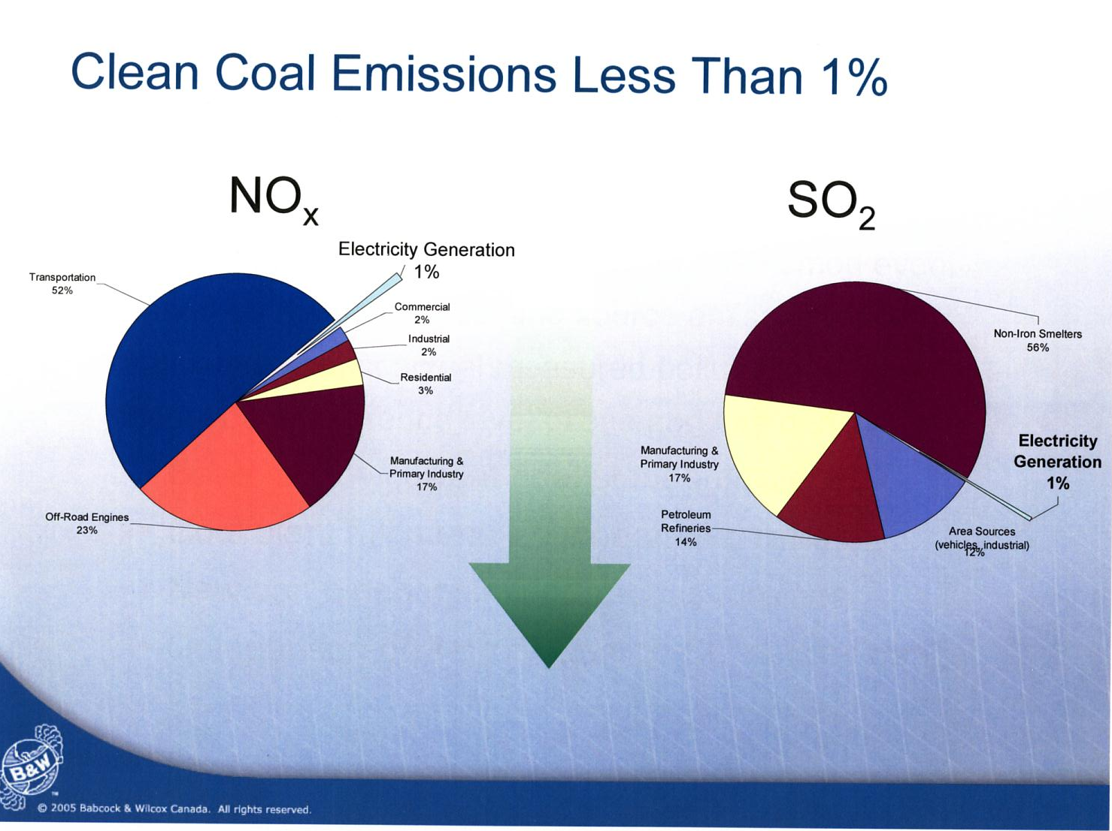

• Existing technology, such as Lambton Generating Station has on 2 units, can reduce emissions by over 80% - to 90%.

• Existing technology can reduce:
- 95-99% of particulate matter
- 90+ % of NOx and SO2
- Wet Electrostatic Precipitators can reduce 95% of acid mists
- Mercury up to 90% - other metals 95%

One Example:
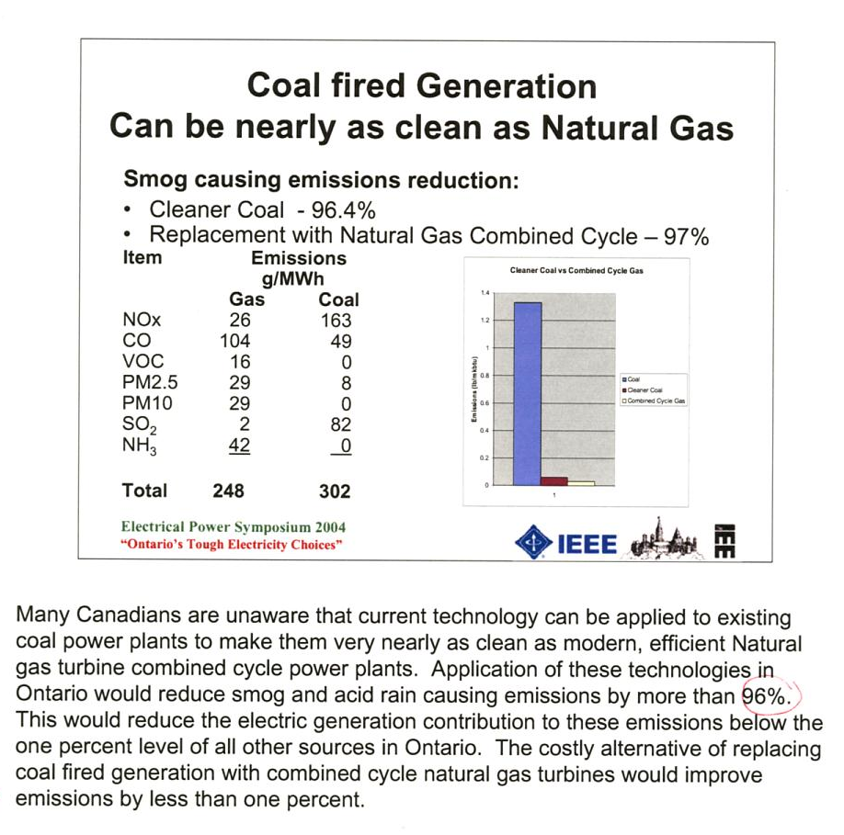
(Babcock & Wilcox)

•The World Energy Council is the “sole global body looking at energy in its totality. Its mission is to promote the wise and sustainable supply and use of energy for the greatest benefit of all people.” The Energy Council of Canada, our national member of this organization, is made up of representatives from across the full spectrum of Canada’s energy sector, including the federal government and many provincial and territorial energy departments and agencies. In their submission to the OPA, the Energy Council provided a number of lengthy documents including, “Sustainable Global Energy Development: The Case for Coal” and “Comparison of Energy Systems using Life Cycle Assessment”. A review of the former includes the statement that, “...many stakeholders do not realize that there is a significant difference between coal's perceived image and its real performance. The report concludes that coal is not part of the problem of sustainable development ... Coal is part of the solution. Coal can be and will be increasingly clean.”
• “Many people have the perception that ‘Clean Coal’ is an oxy-moron, however, we do have the technology to make this a reality. Coal-fired electricity plants can be retrofitted or built so that they produce low to zero emissions...” Natural Resources Canada – Clean Coal Technology Road Map

• “The majority of jurisdictions in Canada (including the federal government and Alberta) set air emissions standards based on 'the best technology available that has been demonstrated to be economically feasible...'. This form of environmental regulation does not dictate the specific technology or the fuel; rather, it sets the upper limit of emissions for each generation type. In Canada therefore, any environmental drive to use natural gas as a fuel source does not come from the need to limit absolute emissions; it comes from broader political and public wills. The Ontario government's plan to eliminate coal plants in Ontario, reportedly pursued to improve public health ... has the potential to dramatically increase natural gas demand in Canada." – The Conference Board of Canada - October, 2004

• “According to Clearing the Air, coal will remain the dominant fuel source for power generation for the foreseeable future. ‘CERA believes under any scenario to 2020, coal will remain the preeminent fuel for power generation, but that changing emission policies will result in significant shifts in coal distribution patterns ... Increasingly stringent environmental requirements will not force the retirement of many coal plants, and the value of efficient, large coal-fired power plants may actually increase rather than decrease with stringent environmental programs.” (Cambridge Energy Research Associates – “Strict New Limits will Force Major Air Pollution Cuts, Shift Utility Strategies & Keep Coal the Dominant Fuel”
November 22, 2004 - www.cera.com)

• The cleanest coal plant in the world, in Copenhagen Denmark, “... has an overall emission profile that’s better than the gas-fired plants now being built in Ontario.” (Energy Probe)

• A recent study conducted by the reputable, and unbiased Energy Probe indicates that “We believe that cleaner coal – like these two units (3 and 4 at Lambton Generating Station) or better, as discussed below – can achieve emissions, power cost, public safety, and fuel diversity advantages over gas-fired generation, which the OCAA promotes and which the Ontario government is now developing. Furthermore, we believe that shutting down these two units – ranked in the top nine cleanest coal-fired generators in North America - would actually worsen air pollution in Ontario, not improve it. We also urge the OCAA to support new cleaner coal options for meeting most of Ontario’s future electricity needs that cannot be served by cost-effective renewable energy alternatives and conservation.... Health hazards from coal-fired power are largely controllable.” (Energy Probe – entire document is attached.)

• The recent OPA Report suggests allowing dual fuel capability for new gas fired generating stations, because there may not be enough gas in winter to provide for both home heating and electricity. The environmental impacts of oil use, the most detrimental to air quality, have not been included in any assessment.

• Coal-fired power generation has been targeted for removal although it represents less than 7% of emissions attributed to air pollution in Ontario. Retrofitting these facilities to reduce that level to about 1% would save billions of dollars otherwise spent to implement gas-fired generation. This could be redirected to address the remaining 93-94% of provincial air pollution.

4. Greenhouse Gas Emissions

• “According to the Intergovernmental Panel on Climate Change, a United Nations organization that periodically reports on greenhouse gas emissions and global climate conditions, the vast majority of carbon dioxide emissions worldwide - about 96 percent - come from natural sources. About 4 percent comes from human activity, including the burning of fossil fuels.” (Partners for Affordable Energy)

• Canada contributes about 2% of that 4% (0.08%) of human related CO₂ emissions.
According to Environment Canada statistics, all electricity production in Canada accounts for 18.38% of national greenhouse gas emissions. This includes CO2, CH4 (methane), N₂O (nitrous oxide). Oil and gas production and distribution accounts for more than this, at 18.78%; transportation, 24.32%; mining and manufacturing, 15.41%; residential, 11.35%; agriculture, 8.38%, and waste, 3.38%. (Canada’s Greenhouse Gas Inventory Overview 1990-2003 – produced October, 2005 – Environment Canada)
Therefore, Canadian electricity production contributes 0.0147% to global greenhouse gas emissions. Ontario thermal generation accounts for about 20% of Canadian thermal generation and therefore contributions from Ontario power production accounts for about 0.0029% of global greenhouse gas emissions.

• Deforestation, from urbanization and world demand for wood products, has had an impact on increasing concentrations of carbon dioxide in the atmosphere. Trees act as carbon sinks, removing carbon dioxide from the atmosphere. It is estimated that, because of deforestation, about 1 – 1.5 billion tonnes of carbon dioxide that would have been removed from the atmosphere each year by trees, remains and contributes to the greenhouse effect.
• Greenhouse gas emissions have increased in Canada from 1990 to 2003. Although electricity and steam production account for a large portion of those increases, 42% of the increase is as a result of “fugitive releases (e.g. methane leaks from pipelines)... most of this increase is the result of greater traffic through energy pipelines...” (Environment Canada – Summary of Canada’s Greenhouse Gas Inventory)
• Transportation is one of the largest sources of Canadian carbon dioxide emissions. Roughly half of the carbon dioxide emissions from the transportation sector are created by the cars and light trucks we drive for personal use. The rise in transportation emissions is attributed to growth in use of SUVs and minivans, which almost doubled between 1990 and 2003.
• In Canada, natural gas is a larger source of carbon dioxide emissions than coal. (John H. Walsh, Energy Advisor, 2004 Carbon Dioxide Fact Sheet – jhwalsh/index.html)

• The World Energy Council reports that “If life cycle analysis was used and other greenhouse gases were taken into account, electricity generation from fuels other than coal would show similar or even higher GHG emissions. ... the projected increase in annual emissions of carbon dioxide from coal between 2001 and 2025 of 1.1 billion metric tons of carbon equivalent will be less than the increased amount for either natural gas (1.3 billion tons) or oil (1.5 billion tons)”

•“Burning gas instead of coal also sounds good and green since it cuts CO₂ emissions in half. In practice it may be the most dangerous energy source of all, because natural gas is 23 times as potent a greenhouse gas as CO₂. During the next critical 20 to 50 years even a 2 percent leak of the natural gas from the production sites to the power stations makes it as bad as burning coal. In practice, the leak rate is 4 percent, so it may be more than twice as bad as burning coal or oil.” (Mr. James Lovelock - address to the Canadian Nuclear Association Annual Seminar, March 10, 2005)
Mitigating the Damage

• In some countries, like Denmark, Germany, Japan, straw and wood pellets, even municipal waste (biomass) is burned with coal to minimize the CO₂ emissions.

• Increasing boiler efficiency for coal generation successfully reduces CO₂ emissions.

• Although still in the early stages of development, geological sequestration of CO₂ is a promising solution and viable for southwestern Ontario.

• “Canada is well positioned to become a world leader in the application of this technology because of the acknowledged excellence of the ongoing work on both clean coal and carbon dioxide capture and storage technology.” (Natural Resources Canada – Canada’s Clean Coal Technology Roadmap)

5. A POWERful Option:

The provincial government is out of step not only with other world jurisdictions that are increasing the use of coal-fired generation, but our own federal government.

“In Canada and globally, there are huge proven reserves of coal which contribute enormously to our energy mix and to our nation's economic prosperity. To not continue to use coal is to deny many Canadians access to an inexpensive, secure and readily available fuel, which is free from price volatility and completely capable of being utilized in an environmentally acceptable manner - as this Clean Coal Technology Roadmap illustrates." (Natural Resources Canada’s Canada's “Clean Coal Technology Roadmap” – www.cleancoaltrm.gc.ca)

“Fossil fuels currently supply 80% of the world energy and will continue to provide the majority of energy supply well into the 21st century. Coal is extremely important ... because while production is peaking for oil and natural gas, coal exists in abundance... future supply-risk raises serious concerns about North American gas. ... Coal is the world’s most abundant conventional energy source, accounting for 60% of remaining world hydrocarbon reserves, and 91% in the US and Canada combined (not including oil sands and oil shale) National Energy Board, 2003” (Natural Resources Canada)

When the federal government developed Canada’s “Climate Change Action Plan 2000”, the Technology and Innovation program was devised as a crucial element for forward planning. “The importance of developing a clean coal strategy for Canada as part of a larger clean energy agenda was immediately recognized.” Coal was not put on the chopping block. It is too valuable a commodity. But like nations already ahead in research and development, the federal government chose to move quickly to advance current and emerging technologies to ensure that Canadians enjoy “... economically priced power without environmental compromise.” Ontario could and should be a part of the resurgence of coal-fired generation.

SUMMARY

Coal fired generation is affordable, available on demand, provides generating characteristics that balance and stabilize the power production grid, and can be environmentally clean. Replacing coal with natural gas power generation will result in approximately 1% emissions improvement at billions of dollars of cost for transmission reconfiguration, major gas storage and infrastructure changes and double the fuel costs. Many other associated costs factor in to make this an economically detrimental decision.
The solution is not less coal, but better use of coal.
APPENDIX – Health Damages - Expanded

Coal-fired electricity generating plants do contribute to the overall air pollution in Ontario, but they are by no means the greatest contributor.
The Government claims the Coal Fired Generating Stations (CFG’s) are responsible for 668 deaths and $3.0 billion/year Health Damages annually.
Examining the $3.0 Billion, only $0.3 Billion are estimates of actual costs incurred. The remaining 2.7Billion, the significant majority, is a theoretical “value”, not an actual cost, as we are led to believe.
This theoretical number is derived from an estimate of the risk of premature mortality due to the CFG’s. Note risk, not certainty. A group of people were then asked what they would be willing to pay (WTP) to reduce this risk, i.e a form of insurance premium. The value of a statistical life (VSL) is then derived by dividing the WTP by the change in risk.
In reviewing the original research report that was used as a basis for the government commissioned report, the following “anomaly” is apparent. In situations where people are willing to pay more per year for a higher reduction in risk, the Value of a Statistical Life comes out to be lower than for those willing to pay less for a smaller reduction in risk. There is no doubt that the math is correct, the “discrepancy” being the result of a nonlinear relationship between increasing risk and willingness to pay. This indicates the very high variability of results from this kind of statistical analysis. The value of a statistical life used in the Report is $4,180,000.
The risk of premature death derived in the Report is 650/14,000,000 (number of estimated deaths divided by the population at risk) or 0.46 per 10,000. The amount that people are therefore willing to pay comes out to be $192.
This means that the government believes that every man women and child in Ontario is prepared to pay $192/year to possibly extend the life, by a few years, of 650 random people whose primary cause of death will, in the end, not be due to pollution.

A quote from the DSS Report: “In actual fact, it is impossible to identify which specific deaths that occur over a given time are actually attributable to pollution. Air pollution is a contributory factor in a multitude of deaths and is almost never the overriding or irrefutable single cause of death.”

If you really believe that the Coal-Fired plants are responsible for 668 deaths per year, go ask the government for the names of those on last years list. Of course they will not be able to name one person. There has never been a death certificate issued giving the cause of death as “Pollution from Coal Fired Generating Plants”

So the $2.7 Billion ($192 x 14,000,000) “Health Damages” is not actually being spent by the government, as we are led to believe, as justification for replacing the coal fired generating plants with natural gas fired plants.

Let’s see what this means to the “average family” of 2.5 persons.

Cost to Replace Coal Fired Electricity Generation
Annual Cost for Family

$192 x 2.5 (health damages mitigation) $481
Smart Meter * $80
Increased Electricity cost $500
Increased natural gas cost $500
Total $1,561

*$40/yr additional billing cost, $40/yr meter depreciation cost

Note : The $1,561 is in addition to existing utilities costs

This cost is just to replace pollution from the coal-fired generating plants, just 6% of the total pollution. In other words when it is all over, the average family will be burdened with approximately $1,500 per year more for utilities and still be exposed to 94% of the pollution and the associated “would be” over 10,000 premature deaths. (from sources other than the Coal –fired generating stations).

To put this issue into perspective let’s compare it to road traffic and related deaths.

Vehicular traffic pollution is twice that of the coal fired generating plants and there are over 800 “real deaths” and 71,000 injuries on Ontario’s roads each year. Do you hear anyone suggesting we ban all road traffic to solve this problem??? Absolutely not! So, the Governments policy to close the coal-fired plants has nothing to do with pollution or deaths. It is difficult to fathom what the actual reasons are.

